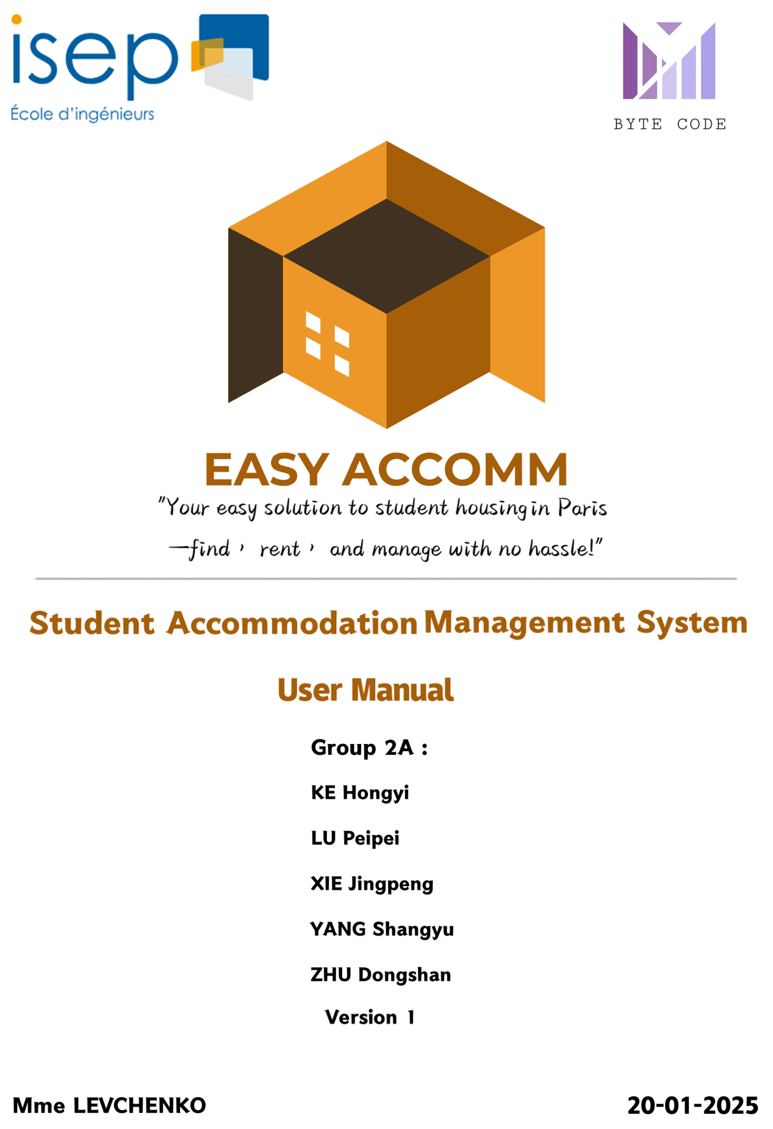

**Student Accommodation Management System**

**Introduction**

Project Background: a comprehensive platform designed to meet the housing needs of

students and landlords in Paris. Our platform simplifies the process of finding, renting, and managing student accommodation.

**Project Requirements**

Our platform aims to meet the housing needs of three main user groups:

**1. Students**

Target Group: International and local students seeking affordable and suitable

accommodation in Paris.

Requirement: Provide an easy-to-use interface for students to search, filter, and apply for accommodation based on location, budget, and amenities. Ensure the process is efficient and transparent.

**2. Recent Graduates**

Target Group: Young professionals starting their careers in Paris and requiring housing solutions.

Requirement: Enable recent graduates to find transitional housing that meets their needs for convenience, affordability, and access to work locations.

**3.Landlords**

Target Group: Property owners in Paris looking to rent out their properties to students and young professionals.

Requirement: Offer landlords a platform where they can list, manage, and rent out

properties efficiently, with tools for tenant management and communication.

**Functional Description**

**Module 1: Student Information Management/Personal**

Account Management

Function:

This feature allows users to create and manage their accounts, including

registration, profile updates, password resets, and identity verification for enhanced security and convenience.

**Step1:Register**

1.After the user enters the homepage, he can see the registration button on the far right of the navigation bar.

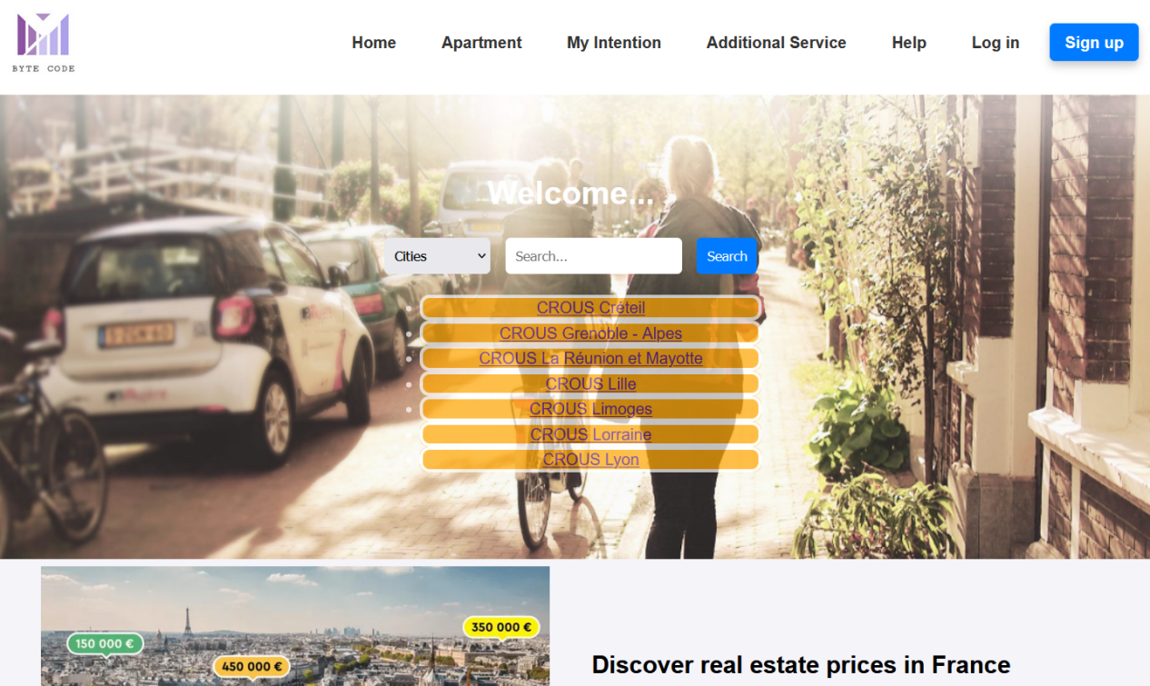

2.Click to enter the registration page. The system defaults to being a tenant, but you can also choose to register as a landlord.

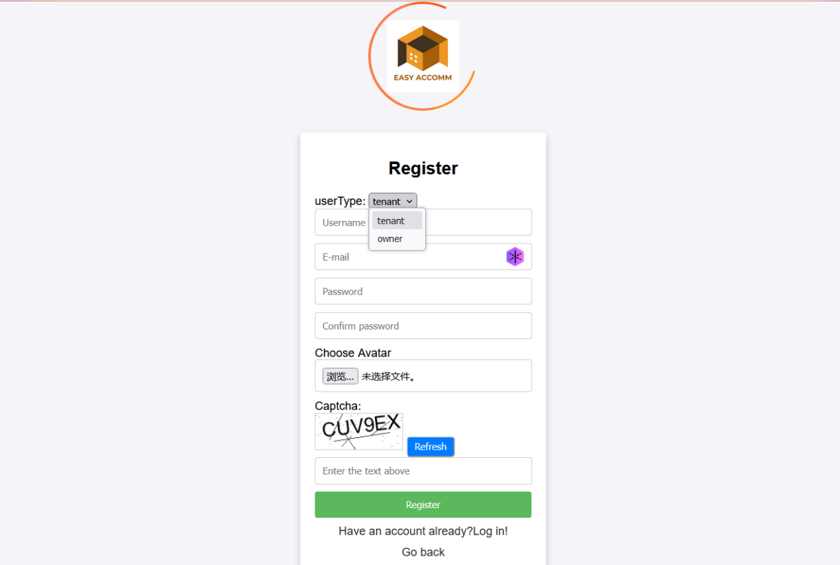

1. After selecting the user type, filling in the user name, email address, password, uploading the avatar, and filling in the graphic verification code (make sure the user name is available, the email address format is correct, and the password entered twice is the same), you can complete the registration.

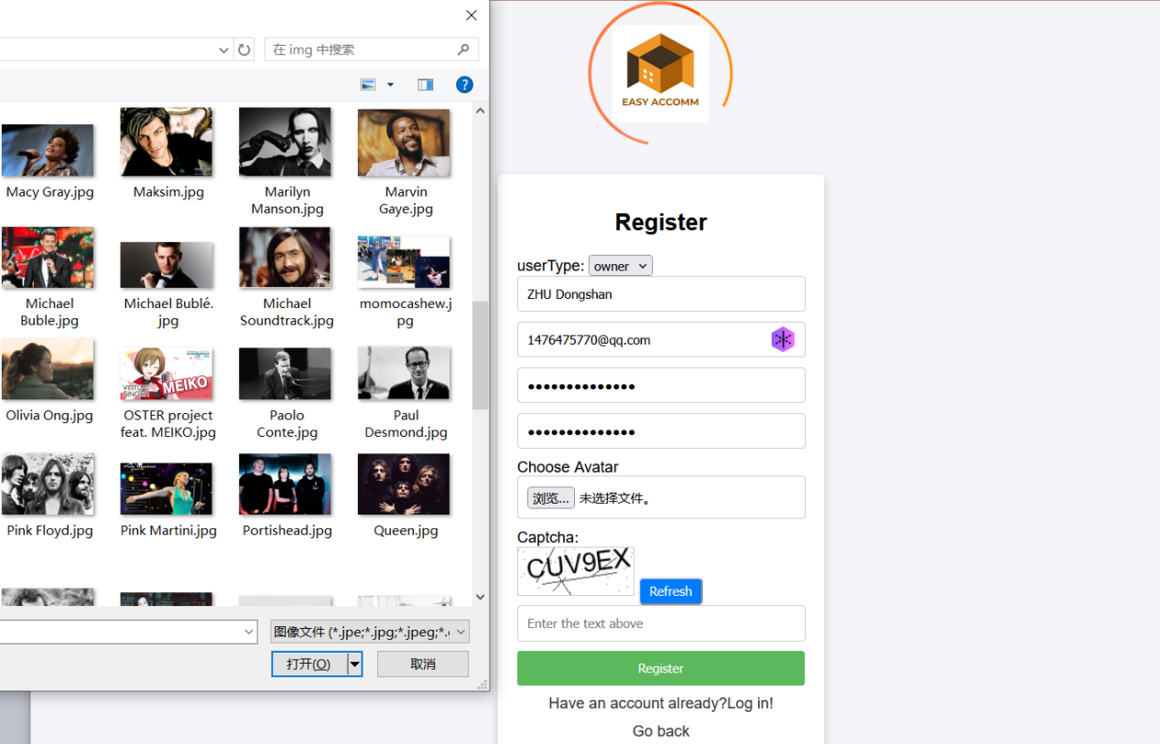

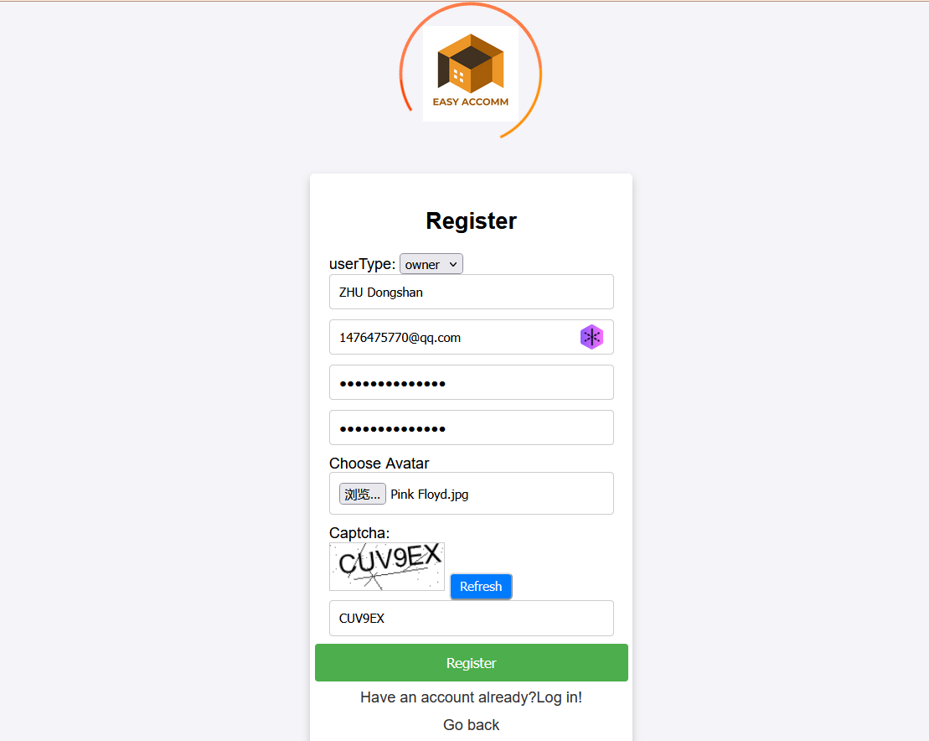

**Step2:Log in**

1. After successful registration, the user will be redirected to the login page and can log in successfully by entering the correct username and password.

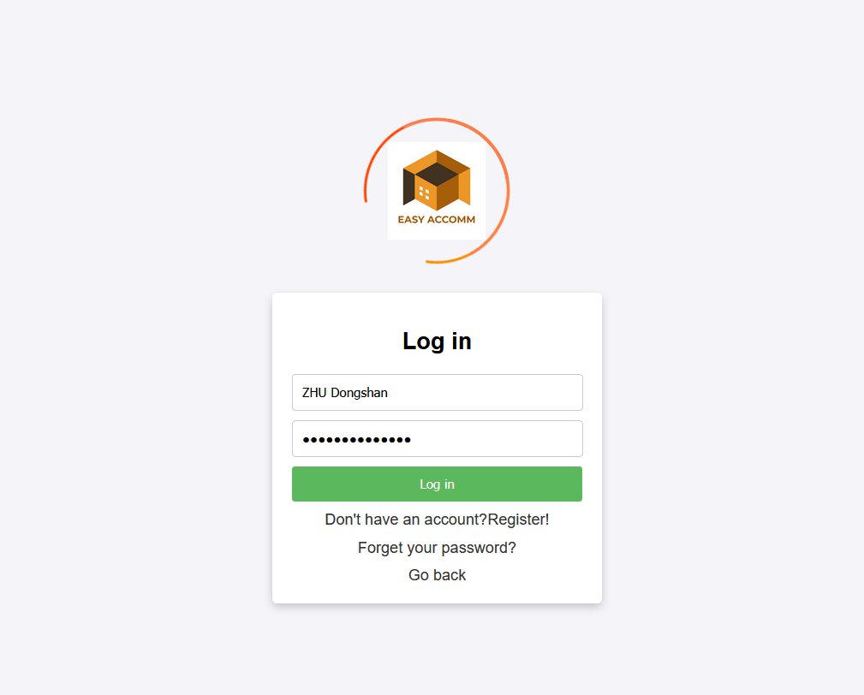

**Step3:Account management**

1.After the user successfully logs in, he will be redirected to the homepage, which will display the user's avatar and user name, replacing the original login and registration buttons.

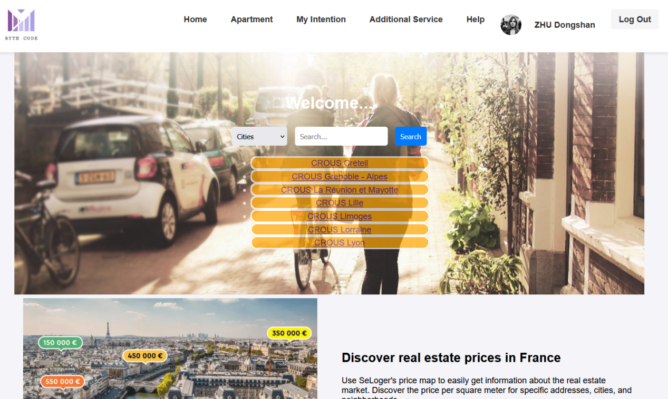

1. At this time, there is a logout button on the far left of the navigation bar. After clicking it, the user logs out and returns to the default state.

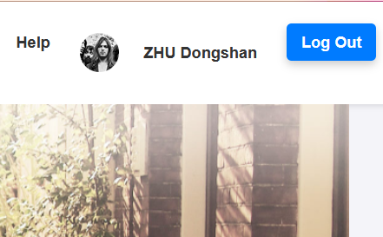 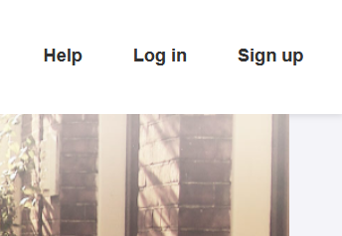

1. If the user needs to reset the password, he can click "Forgot your password?" on the login page to enter the password reset page.

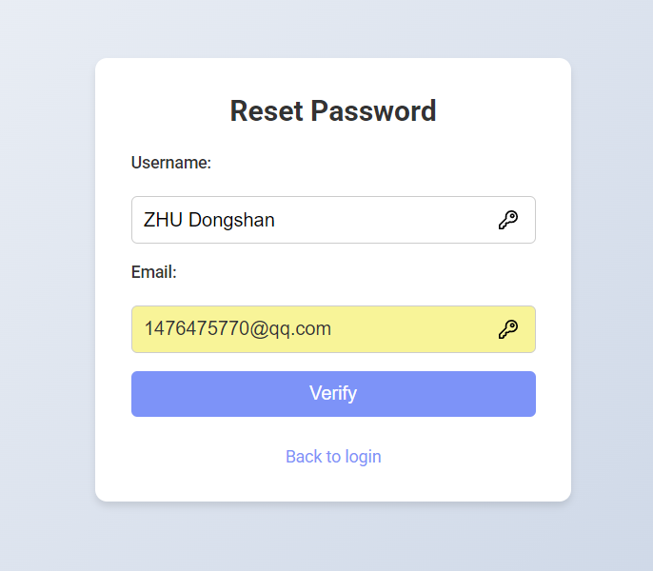

1. After entering the email address corresponding to the username for verification, you can set a new password.

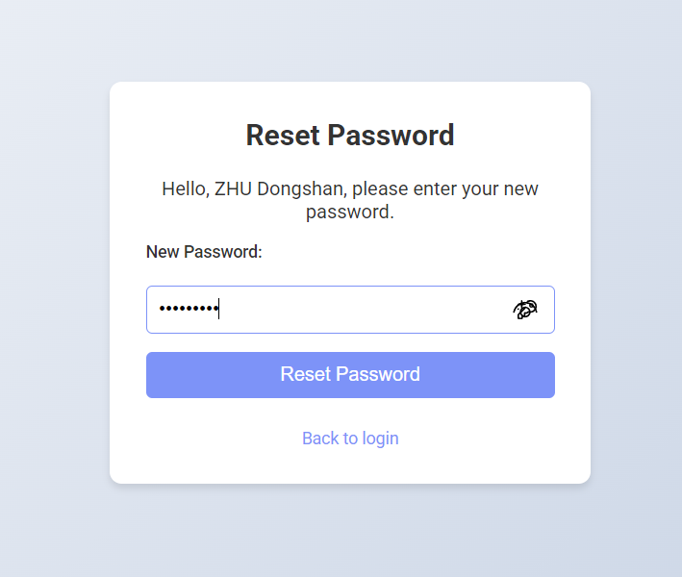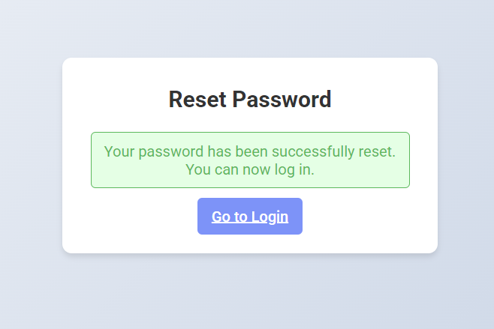

1. Click your username in the navigation bar to enter the account details page (tenants can manage personal information, and landlords can manage personal properties).

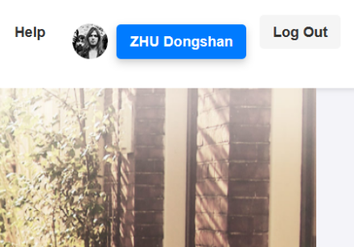

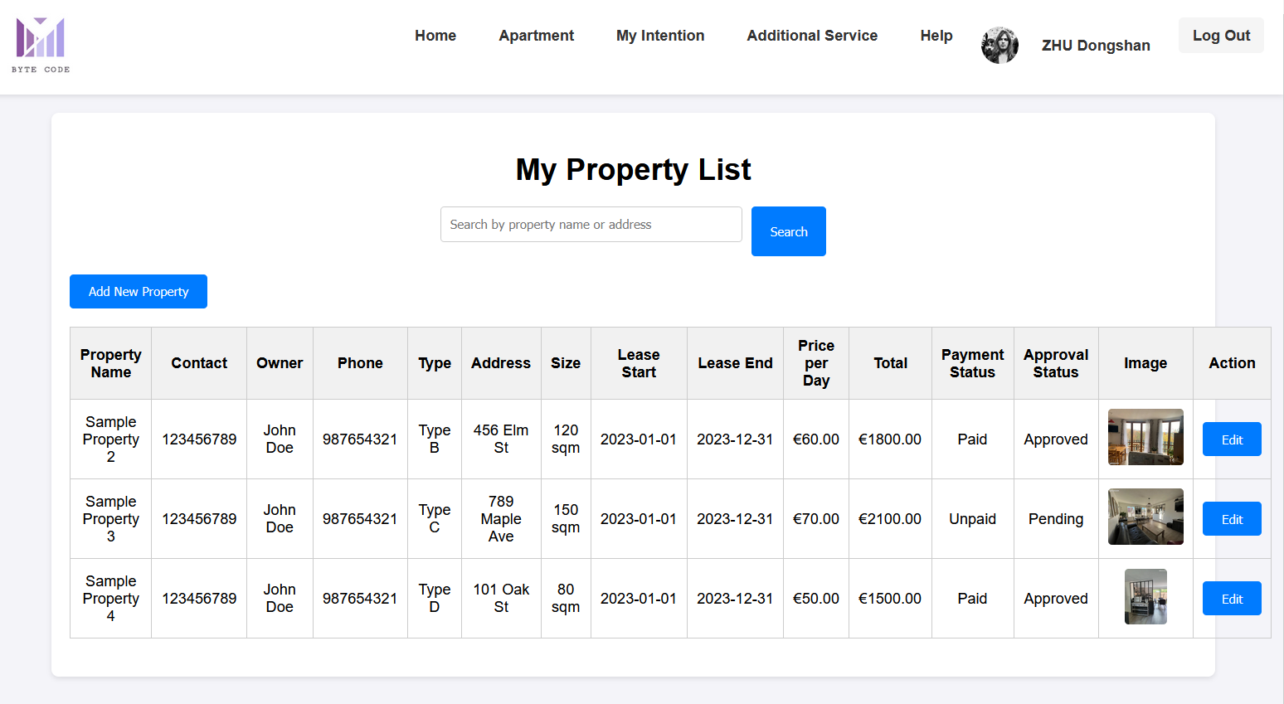

**Module 2: Housing Search**

Function:This feature enables users to efficiently search for available accommodations based on their preferences, including location, price range, and amenities.

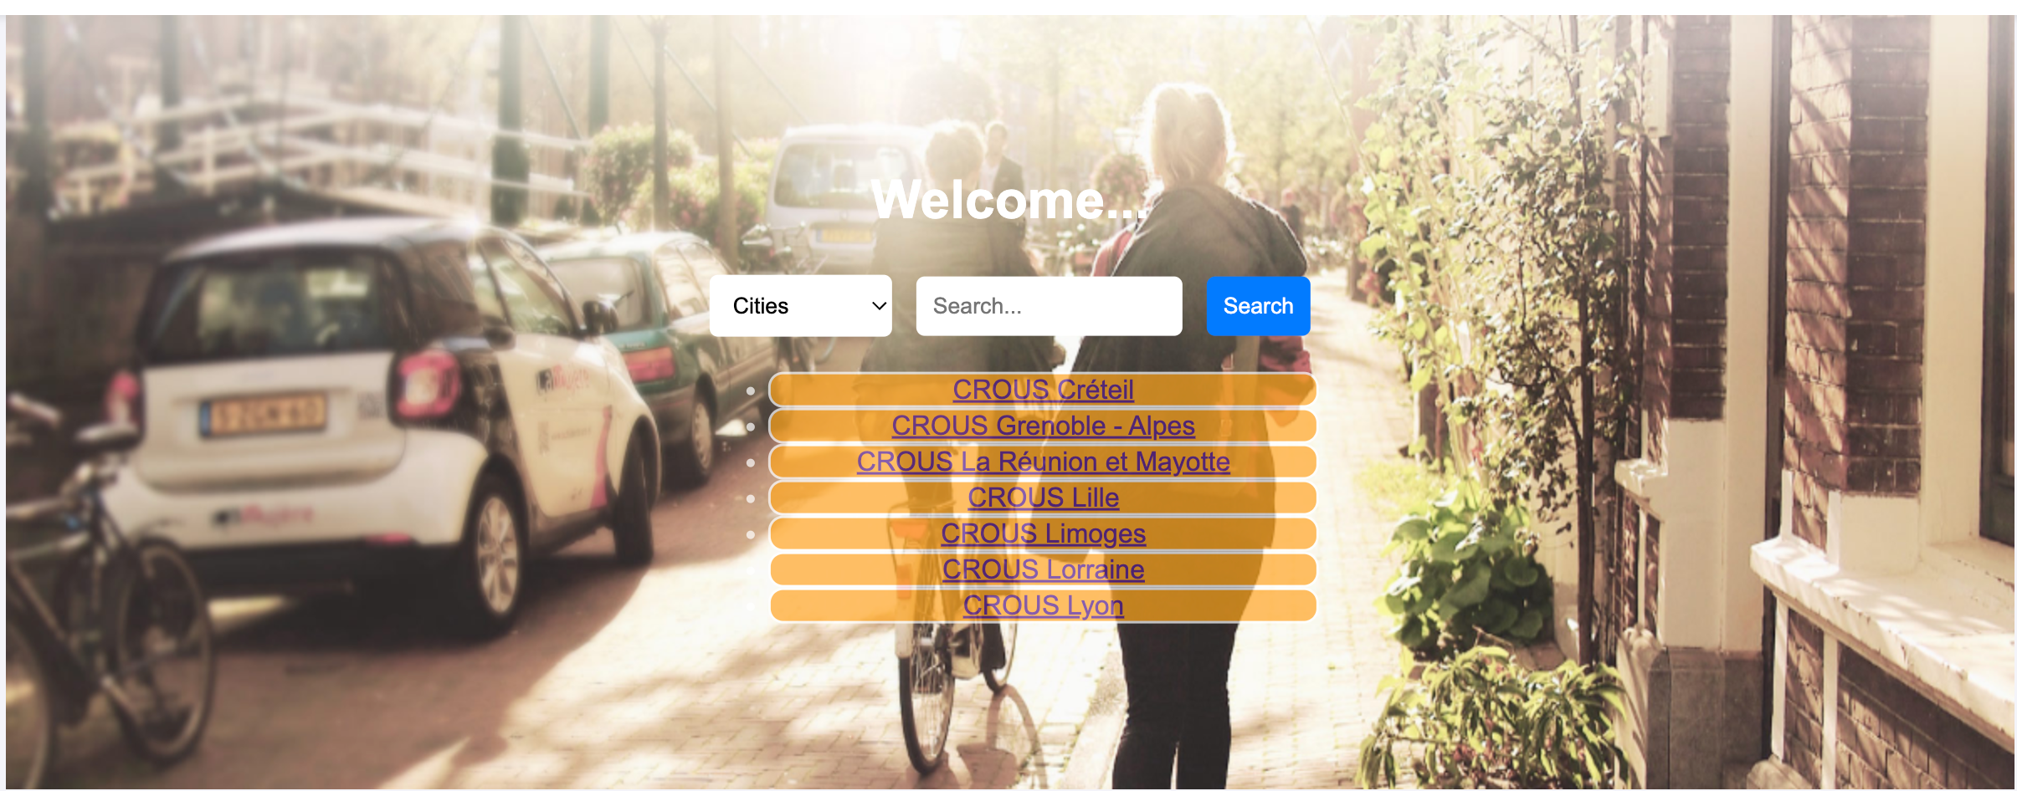

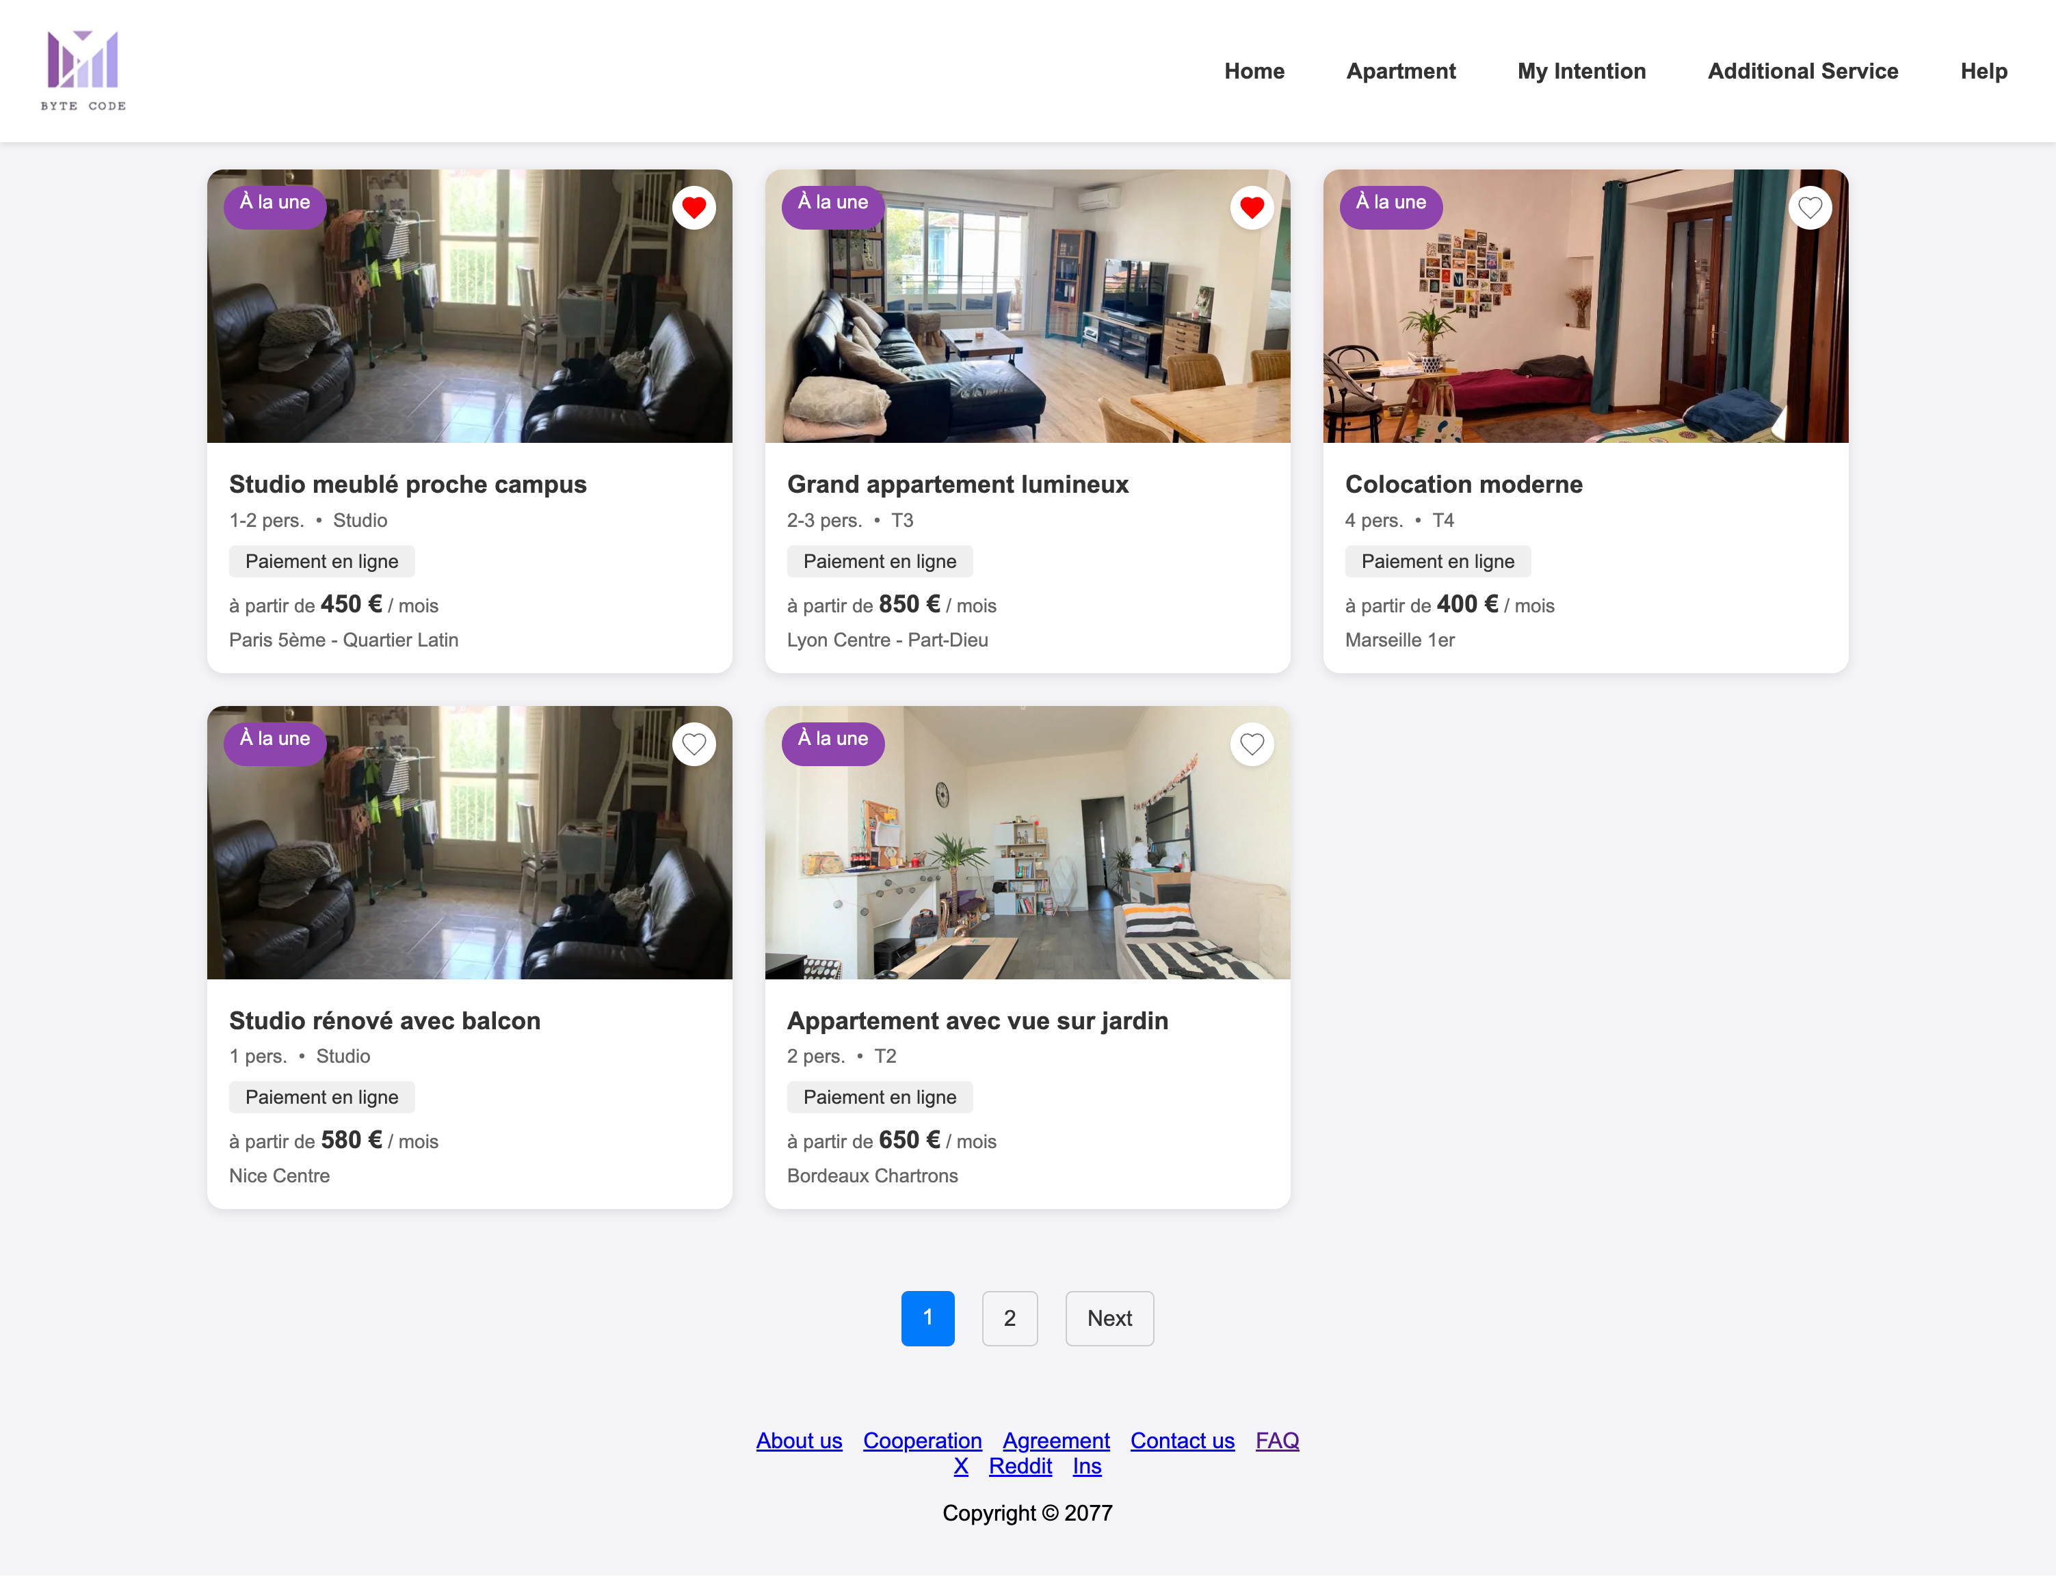

**Module 3: Communication and Contact**

Function:This feature facilitates seamless communication between users and landlords,allowing for inquiries, discussions about properties, and timely responses to ensure a smooth rental experience.

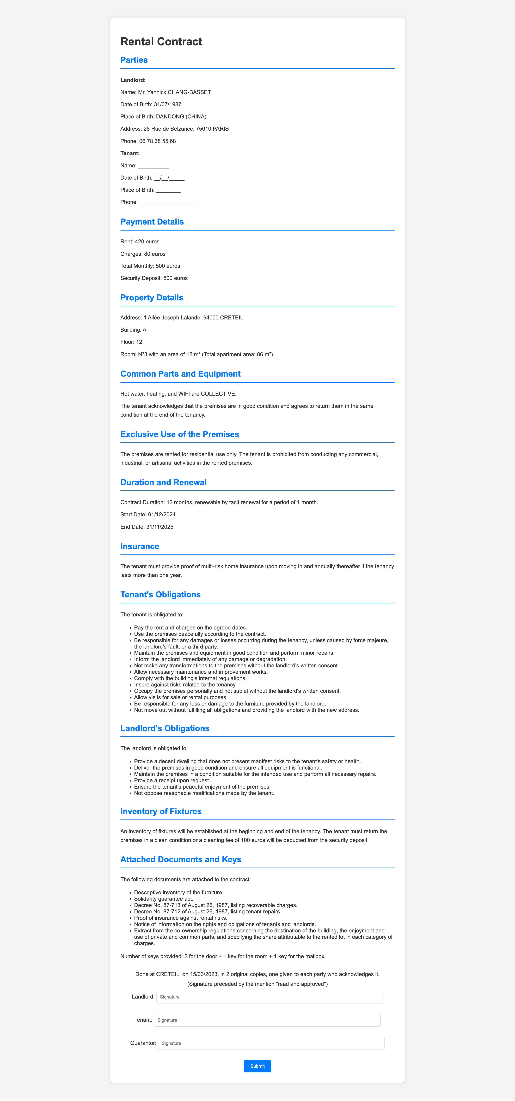

**Module 4: Favorite Properties and Shortlist**

Function:This feature allows users to save and manage their preferred accommodations,enabling them to easily revisit and compare their shortlisted properties for informed decision-making.

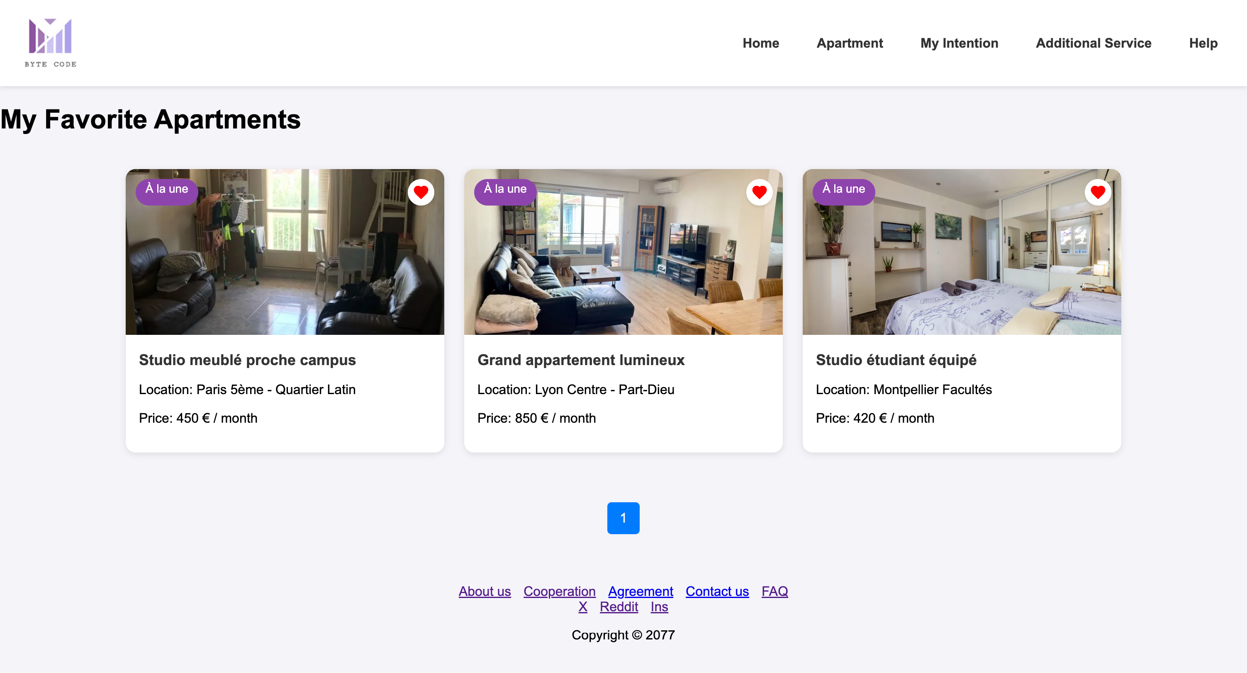

**Module 5: Additional Services**

Function: The additional services page provides functions related to scholarships, accommodation and other student needs, including scholarship simulation calculation, application and tracking, student guides, accommodation information for Crous dormitories, Paris-Saclay campus and private housing, and supports the use of Visale guarantee services. There are also functions for finding part-time students and recommending restaurants/accommodations. The right side also provides instructions on CVEC student life payment, phishing warnings and account security tips. It is a comprehensive service page to help students deal with study and life affairs.

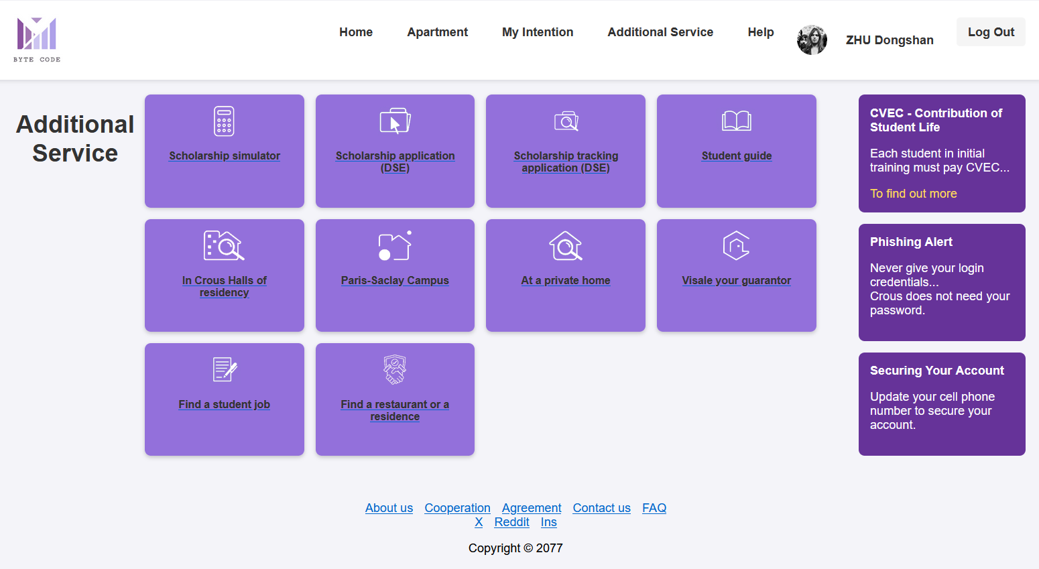

**Module 5: Apartment**

Function: The Apartment module is a feature interface that showcases property listings, allowing users to quickly browse, filter, and select the accommodations that best suit their needs.

